DATA PROTECTION USING HYBRID ENCRYPTION AND STEGANOGRAPHY
Methodology, Novelty and Key Contributions
Department of Computer Science and Engineering, TKR College of Engineering & Technology
Batch A15 (CSE-A) · Academic year [ACADEMIC YEAR]
Table 1: Project team
S.No. | Student name | Roll number
1 | Allam Rakesh | 23K91A0509
2 | Bolleddu Shanker | 23K91A0543
3 | Agaram Sri Sarvagna | 23K91A0506
4 | B Akshay | 24K915A0504

Project guide: Rajalakshmi
Chapter and section numbers quoted in the text (for example Chapter 8 or Section 6.2) refer to the full project report, 17.Final Document. Figures and tables in this document are numbered from 1.

1. METHODOLOGY
This document describes how CipherVeil works from end to end and what is new in it. Part 1 gives the pipeline, the data, the algorithms and the reasons they were chosen; Part 2 sets the work against the base paper and separates what is new from what is standard; Part 3 lists the contributions.

1.1 Overall methodology
CipherVeil treats data protection as one measurable pipeline with two layers. The first layer is cryptographic: a file is encrypted with a fresh AES-256-GCM key, and that key is wrapped with the receiver's RSA public key. The second layer is steganographic: the resulting byte bundle is written into the least significant bits of a cover image and saved as a PNG. The base paper [1] hides secret bits among random decoy bits so that an untrusted party can compute on them; CipherVeil keeps its choice of the least significant bit as the carrier but pursues a different goal, moving a whole file from a sender to a receiver, and so adds standard authenticated encryption, a capacity check and a measurement of what the hiding costs.
The work was carried out in six steps, each with a check that decides whether the step is finished.
1. Choose the primitives. AES-256-GCM, RSA-OAEP with SHA-256, and one-bit LSB substitution in the three colour channels, all from well-reviewed standards and libraries, with no new cryptography.
2. Fix the bundle format. One self-describing byte string (magic, wrapped key, nonce, ciphertext with tag) so that the receiver needs nothing but the image and a private key.
3. Build the pipeline. crypto.py, lsb.py, metrics.py and pipeline.py as pure functions with no web code, so the same functions serve the API, the benchmark, the evaluation script and the tests.
4. Wrap it in an application. A FastAPI service with login, key storage, send, receive, analysis, robustness and log routes, and a React console for the eight screens.
5. Measure. ml/eval.py (22 round trips, nine attacks) and scripts/run_experiments.py (RSA key size, fill ratio, plain against encrypted bits, steganalysis, tamper study, extra attacks).
6. Test. 39 automated tests, a 21-check smoke script against the running server, and a screen walk with real data.
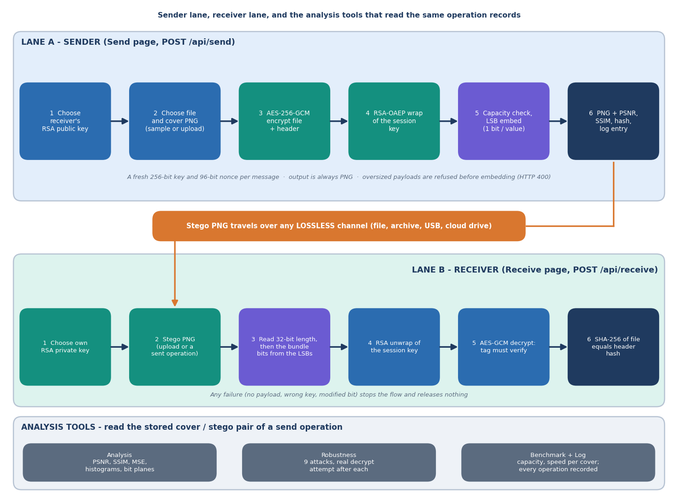
Figure 1: Methodology as a pipeline: key generation, encryption, wrapping, capacity check, embedding, extraction, decryption and measurement.

1.2 Data
CipherVeil learns nothing from data, so there is no training set, validation set or test split, and none of the results depends on a random split. What the evaluation needs is a set of cover images of different sizes and content and a set of payloads of different sizes. Both are small, are committed to the repository, and are regenerated by the seeded script scripts/make_samples.py. Any image or file uploaded at run time can replace them, up to 25 MB.
Table 2: Cover images used in every experiment.
Cover | Pixels | File size | Source and licence
astronaut_512x512.png | 512 x 512 | 422,355 B | scikit-image data.astronaut(), NASA photograph, public domain
cat_451x300.png | 451 x 300 | 218,916 B | scikit-image data.chelsea(), CC0
coffee_600x400.png | 600 x 400 | 441,801 B | scikit-image data.coffee(), CC0
coffee_small_200x200.png | 200 x 200 | 70,651 B | crop and resize of data.coffee(), CC0
generated_landscape_1280x720.png | 1280 x 720 | 1,234,411 B | procedural, seed 11, generated for this project
rocket_640x427.png | 640 x 427 | 303,107 B | scikit-image data.rocket(), public domain

Table 3: Payloads used in the experiments.
Payload | Size | Nature
accounts.csv | 2,774 B | synthetic table of accounts, generated here; used for the robustness grid
confidential_memo.pdf | 21,517 B | synthetic one-page memo, generated here
meeting_notes.txt | 169 B | synthetic text
settings.json | 99 B | synthetic JSON

The core evaluation crosses the six covers with random payloads of 1, 4, 16, 64 and 128 KiB: 30 combinations, of which 22 fit and 8 are blocked by the capacity check (Section 6.5.1). The fill-ratio study crosses the six covers with seven fill levels from 1 % to 100 % and five random payload seeds, 210 embeddings in all. Three limits of this data are stated here because later chapters depend on them: the covers are six images, none taken by a camera; the payloads are small and synthetic; and the photographs are natural-image samples shipped with a library, so the statistics seen by the steganalysis experiments are those of these six images only.

1.3 Preprocessing
The only preprocessing is in lsb.load_rgb. Whatever the user uploads is opened with Pillow, fully decoded, converted to three 8-bit channels (RGB) and held as an array of shape height x width x 3. An alpha channel is therefore dropped, a palette or grey-scale image is expanded to RGB, and an input that Pillow cannot read as an image is rejected with a clear message. The payload is not preprocessed at all: it is hashed with SHA-256, given a small JSON header and encrypted as raw bytes, so any file type works and no compression is applied. On the way out the stego array is written as PNG (compression level 6), the only output format, because PNG is lossless and the hidden bits must survive storage. Section 7.6 shows that an RGBA input round-trips and that re-saving as PNG or lossless WebP keeps the payload while JPEG at quality 100 does not.
def load_rgb(source) -> np.ndarray:
"""Accept bytes or a path; return an HxWx3 uint8 array (alpha dropped)."""
try:
img = Image.open(io.BytesIO(source) if isinstance(source, (bytes, bytearray)) else source)
img.load()
except Exception as exc:
raise StegoError("Could not read this file as an image") from exc
return np.array(img.convert("RGB"), dtype=np.uint8)

1.4 Algorithm choice and justification
Each stage uses the standard component for its job. The table gives the choice, the reason, and the alternatives that were considered and left out; every one of the left-out alternatives is worth doing and is listed as future work in Chapter 10, but none was part of the objectives set for this project.
Table 4: Algorithm choices.
Stage | Chosen | Why | Left out
Data encryption | AES-256-GCM [20], [21] | Authenticated: a flipped bit or wrong key fails the tag check and nothing is released; fast; available in cryptography | CBC or CTR plus a separate MAC; stream ciphers
Key transport | RSA-OAEP, SHA-256, MGF1-SHA-256 [22], [23], [24] | Public-key wrap lets the sender encrypt without a shared secret; OAEP is the padding recommended for encryption; 2048 to 4096 bits | Key agreement (ECDH), elliptic-curve keys, post-quantum KEMs
Session key | Fresh 256-bit key and 96-bit nonce per message | One compromised message key never exposes another; no nonce reuse | Key derived from a password
Carrier | PNG, RGB, 8 bits per channel | Lossless; widely supported; 3 values per pixel | JPEG-domain, audio, video carriers
Embedding | 1-bit LSB replacement, row-major from the first pixel [11], [8] | Simplest scheme with the highest capacity (3.0 bits per pixel) and a closed-form cost; easy to verify byte for byte | LSB matching [12], syndrome-trellis codes [13], key-driven permutation, error-correcting codes [3]
Quality measure | PSNR, MSE, SSIM [27], [26] | Standard imperceptibility measures; stated as objective 5 | Perceptual or learned metrics
Detection check | Chi-square [15] and weighted stego [18], [19] | Two classical detectors that are simple enough to implement and verify here | RS [16] and sample-pair [17] analysis, learned detectors

The most consequential choice is plain sequential LSB replacement. It is the only embedding for which the cost of hiding can be written in one line (Section 6.5.5) and for which every claim can be checked byte for byte, and it matches the base paper's carrier. Its price is known and measured in this project rather than hidden: it does not survive any lossy operation, and its sequential, key-independent layout is detected by the chi-square test in 30 of 30 cases and tracked by the weighted-stego estimate (Chapter 8).

1.5 Mathematical formulation

1.5.1 Bundle length and capacity
Let the file have n bytes and the receiver's RSA key have k bits. The header is a JSON object with the file name, the size and the SHA-256 of the file, of h bytes (116 bytes for accounts.csv, 126 for confidential_memo.pdf). The plaintext under AES-GCM is a two-byte header length, the header and the file. The bundle that is hidden has length L, and a cover of W x H pixels holds C bytes:
L = 4 (magic) + 2 + k/8 (wrapped key) + 12 (nonce) + (2 + h + n) + 16 (tag) = n + h + k/8 + 36 (1)
C = ⌊(3 · W · H − 32) / 8⌋, the send is accepted only if L ≤ C, used = L / C (2)
The 32 bits are the length prefix. For RSA-2048 the overhead L − n is 408 bytes for accounts.csv and 418 for the memo; for a short file name it is 401, 529 and 657 bytes at 2048, 3072 and 4096 bits. The capacity is 3.0 bits per pixel on every cover (2.999 for the 200 x 200 image because of the 32-bit prefix): 3.0 bits per pixel, from 14.6 KiB for the smallest cover to 337.5 KiB for the 1280 x 720 landscape.

1.5.2 Authenticated encryption
AES-GCM with key K, nonce ν and additional data A = CVL1 produces a ciphertext and a 128-bit tag T:
(C_t, T) = AES-GCM-Enc(K, ν, A, M), M = header_len ‖ header ‖ file (3)
Decryption recomputes the tag in constant time and releases M only if it matches. Because the magic is bound in as additional data, a bundle with a different magic fails even if the rest is intact. A change of any single ciphertext, nonce or tag bit therefore causes rejection with overwhelming probability; the tamper study in Chapter 7 confirms this for 240 of 240 flips.

1.5.3 Key wrapping
The 32-byte session key K is encrypted with the receiver's RSA public key (n_r, e = 65537) using OAEP with SHA-256 for both the hash and the mask generation function. The output is exactly k/8 bytes, which is why the receiver can check, before any private-key operation, that the wrapped-key length equals the length of its own key and reject a bundle sent to a key of a different size:
W = RSA-OAEP-Enc(pk_r, K), K = RSA-OAEP-Dec(sk_r, W), |W| = k/8 (4)

1.5.4 Imperceptibility measures
Let X be the cover and Y the stego image, with N = 3 · W · H colour values in 0..255. The mean squared error, the PSNR and the structural similarity are:
MSE = (1/N) Σ (X_i − Y_i)², PSNR = 10 · log10(255² / MSE) dB (5)
SSIM = mean over channels c of ((2 μ_X μ_Y + c1)(2 σ_XY + c2)) / ((μ_X² + μ_Y² + c1)(σ_X² + σ_Y² + c2)) (6)
The implementation uses scikit-image with data range 255; PSNR is reported as undefined (infinite) when no value changed, and SSIM is averaged over the three channels. Above 50 dB the difference is conventionally treated as invisible [27]; the application shows that threshold next to every result.

1.5.5 A closed form for the cost of hiding
Replacing the least significant bit of a value changes the value by exactly one when the new bit differs from the old one and not at all otherwise. Encrypted bits are uniformly random, so each embedded bit changes its value with probability one half. If B = 8 (L + 4) bits are embedded, the expected squared error per value is the number of changed values divided by N:
E[MSE] = (0.5 · B) / N, PSNR ≈ 10 · log10(255² · N / (0.5 · B)) (7)
This depends only on the number of embedded bits, not on the image content. Over 210 embeddings the measured mean PSNR agrees with the formula to within 0.053 dB, and the standard deviation across five random payloads is at most 0.0987 dB. Filling the whole cover (B = N) gives the floor 10 · log10(255² / 0.5) = 51.14 dB, which is what the measurements show (51.14 to 51.17 dB at 100 % fill). The table gives the six-cover averages.
Table 5: Measured PSNR and the closed form, averaged over the six covers (five payload seeds each).
Fill of capacity | Capacity used (%) | PSNR measured (dB) | PSNR formula (dB) | SSIM
1 % | 1.8 | 68.93 | 68.94 | 0.99995
5 % | 5.8 | 63.58 | 63.57 | 0.99975
10 % | 10.7 | 60.85 | 60.85 | 0.99952
25 % | 25.5 | 57.07 | 57.07 | 0.99880
50 % | 50.3 | 54.13 | 54.13 | 0.99766
75 % | 75.0 | 52.39 | 52.39 | 0.99639
100 % | 99.9 | 51.15 | 51.15 | 0.99507

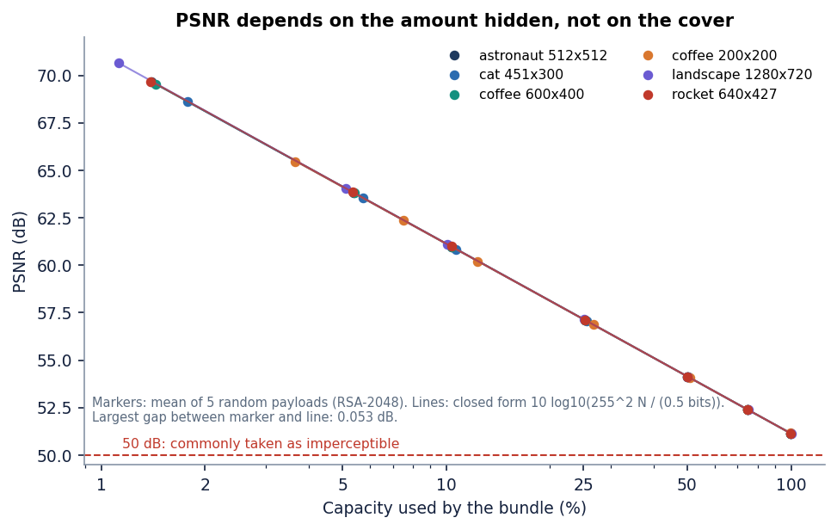
Figure 2: Measured PSNR against the fraction of capacity used for the six covers, with the closed-form curve.

1.5.6 Robustness and detection measures
For each attack the stego image is modified, the whole extract-and-decrypt path is run with the real private key, and the recovered file's SHA-256 is compared with the original. The LSB error rate is the fraction of the first (L + 4) · 8 least significant bits that differ before and after the attack; a value near 0.5 means the bits are as good as random. Two detectors are applied to the cover and the stego image. The Westfeld-Pfitzmann chi-square statistic compares the counts h(2j) and h(2j+1) of each pair of values with their mean e_j = (h(2j) + h(2j+1)) / 2:
χ² = Σ_j (h(2j) − e_j)² / e_j (pairs with e_j ≥ 5), p = 1 − F_χ²(χ²; df = pairs − 1) (8)
Embedding random bits equalises each pair, so p close to 1 on the embedded region signals LSB replacement. The weighted-stego estimate predicts each value from its four neighbours and measures how far the LSB flip moves the value toward that prediction; it returns the embedded fraction of the image. Both are implemented in scripts/run_experiments.py as measurements, not as part of the product.

1.6 Pipeline architecture
The pipeline is two functions in pipeline.py that call small, independently tested services. hide encrypts, checks capacity, embeds, encodes the PNG and computes the quality measures, and times each stage; reveal extracts, unwraps, verifies and hashes. Nothing in these functions knows about HTTP, the database or the screen.
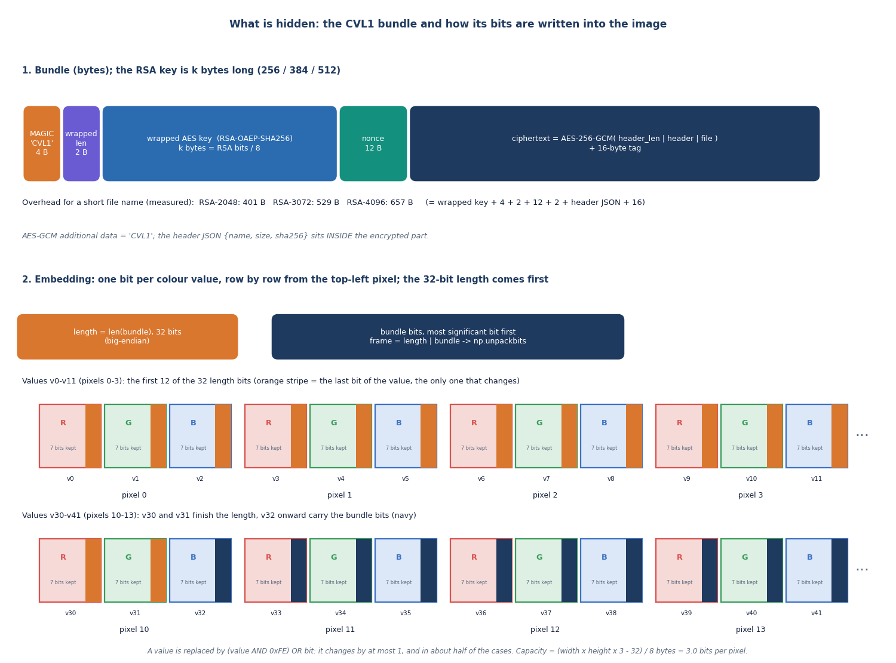
Figure 3: Layout of the CVL1 bundle and its placement in the least significant bits of the cover.
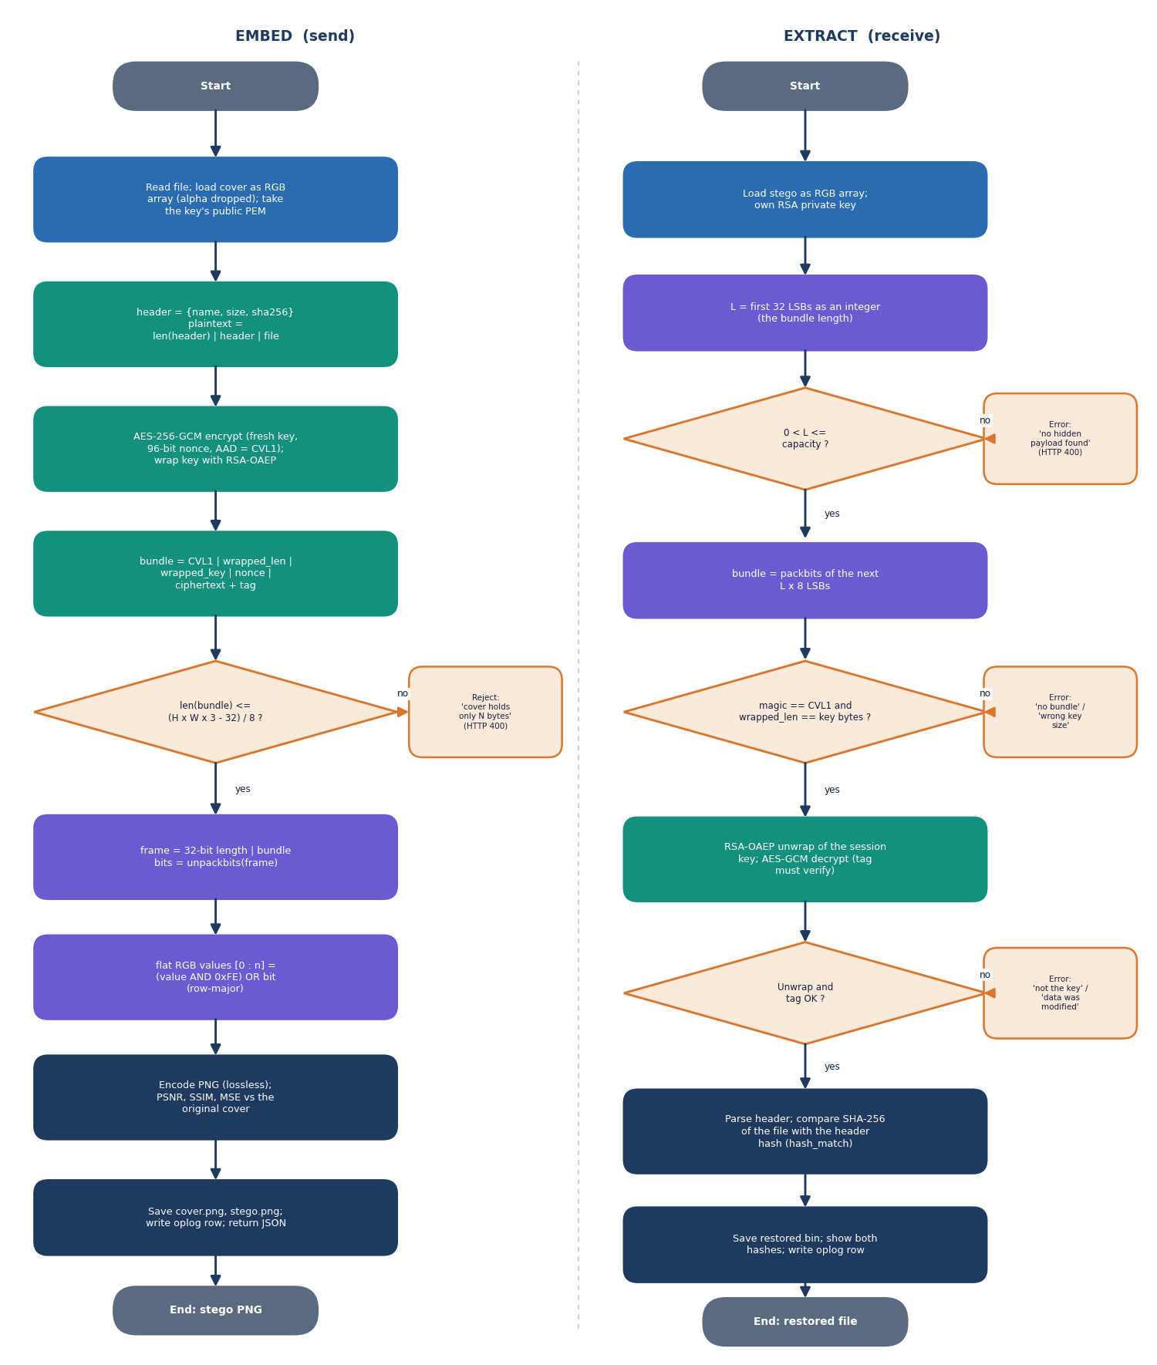
Figure 4: Flowchart of the send and receive algorithm with the points at which a request is rejected.
The embedding and extraction functions are the heart of the system and are short enough to quote in full. Embedding builds the framed bit stream (32-bit length followed by the bundle), unpacks it to bits and overwrites the lowest bit of the first B values; extraction reads the length, refuses an implausible one, and repacks the following bits.
def embed(arr: np.ndarray, bundle: bytes) -> np.ndarray:
cap = capacity_bytes(arr)
if len(bundle) > cap:
raise StegoError(f"Payload needs {len(bundle)} bytes but this cover holds only {cap} bytes. "
"Choose a larger cover or a smaller file.")
framed = len(bundle).to_bytes(4, "big") + bundle
bits = np.unpackbits(np.frombuffer(framed, dtype=np.uint8))
flat = arr.reshape(-1).copy()
flat[:bits.size] = (flat[:bits.size] & 0xFE) | bits
return flat.reshape(arr.shape)

def extract(arr: np.ndarray) -> bytes:
flat = arr.reshape(-1)
if flat.size < LEN_BITS:
raise StegoError("Image is too small to contain a payload")
length = int.from_bytes(np.packbits(flat[:LEN_BITS] & 1).tobytes(), "big")
if length == 0 or length > capacity_bytes(arr):
raise StegoError("No hidden payload found (length header is invalid)")
bits = flat[LEN_BITS:LEN_BITS + length * 8] & 1
return np.packbits(bits).tobytes()

Across the 22 evaluated runs (RSA-3072) the median stage times are 0.15 ms to encrypt and wrap, 0.25 ms to embed, 0.05 ms to extract and 86.37 ms to unwrap and decrypt; the private-key operation is the only cost that is noticeable, and it is paid once per message.

2. NOVELTY AGAINST THE BASE PAPER

2.1 What the base paper contributes
The base paper [1] introduces Provably Secure Homomorphic Steganography (ProSt). A client hides secret bits in the least significant bits of cover images at a secret position (r, c, k), leaving every other least significant bit as an independent random decoy. An honest-but-curious cloud provider then evaluates a Boolean circuit built only from Fredkin gates on every pixel of the images without knowing which bits are secret, and the client reads the result at the secret position of the output image. Theorem 1 of the paper shows that the adversary's advantage in learning the secret bit is of order 1/n in the number n of positions, and the authors recommend n of at least 2^20 (about 10^6). The paper reports no PSNR, SSIM or capacity, because its goal is private computation and not transmission; the only runtime given is 8.38 s for a 17-gate circuit on a 128 x 128 x 3 image.

2.2 What is new in CipherVeil
• An authenticated bundle format. The CVL1 bundle carries the file name, size and SHA-256 inside the AES-GCM layer and uses the four magic bytes as associated data, so a bundle cannot be reinterpreted as another format and the receiver can verify the restored file against the sender's hash.
• A complete hybrid pipeline. A fresh AES-256-GCM key and nonce are made for every message, the key is wrapped with the receiver's RSA public key (OAEP, SHA-256), and the bundle is hidden in a PNG. The base paper leaves key exchange as a remark; CipherVeil implements it end to end.
• A measured embedder. The 1-bit LSB embedder is capacity-aware (3.0 bits per pixel) and its imperceptibility is predicted by a closed-form model that matches measurement within 0.053 dB, which lets a user know the PSNR before sending.
• An honest evaluation. The scheme was tried against 18 attacks, two classical steganalysis detectors and 240 single-bit tamper trials, and the report states what fails: lossy handling and statistical detection.
• A usable tool. A FastAPI and React application with key management, analysis views, robustness and benchmark pages and a log that holds no secrets, backed by 39 tests.

2.3 What is standard
AES in Galois/Counter mode [20], [21], RSA [22] with OAEP padding [23], [24], least significant bit replacement [11], PSNR [27] and SSIM [26] are established techniques used as they are. The chi-square and weighted-stego detectors [15], [18] are published methods applied here as attackers. None of the primitives was invented in this project; the novelty is the integration, the bundle format, the closed-form check and the evaluation.

2.4 What is weaker than the base paper
• No provable security. ProSt proves a bound on the adversary's advantage for locating the secret bit. CipherVeil's security rests on AES-GCM and RSA-OAEP; the hiding layer is not provably secure and is detected by chi-square at the fill levels tested.
• No hidden location. ProSt keeps the position of the secret bit secret. CipherVeil writes from the first pixel in raster order, so anyone who knows the algorithm knows where to read; only the encryption protects the content.
• No computation on hidden data. Homomorphic evaluation with Fredkin gates is outside the scope of this project.
• Weaker than the supporting paper on robustness. SCReedSolo [3] adds Reed-Solomon coding against bit corruption; CipherVeil has no error correction and loses the payload to any lossy change.

3. KEY CONTRIBUTIONS
The contributions of the project, stated at the strength the evidence supports, are:
1. An authenticated bundle format (`CVL1`) that carries the file name, size and SHA-256 inside the AES-GCM layer and uses the magic as associated data, so that the receiver can check the restored file and a bundle cannot be confused with another format.
2. A hybrid pipeline with a fresh key per message: AES-256-GCM with a new 256-bit key and 96-bit nonce for every message, wrapped by RSA-OAEP-SHA256 for the receiver. The file was restored byte for byte in 22 of 22 evaluation runs, and all 240 single-bit tamper trials were rejected.
3. A capacity-aware 1-bit LSB embedder at 3.0 bits per pixel whose closed-form PSNR model matches measurement within 0.053 dB; PSNR was never below 51.1 dB at any fill level on six covers.
4. An honest evaluation: of 18 attacks only the lossless ones survive (5 of 18), the chi-square test flags the embedded region in 30 of 30 cases, and the weighted-stego estimator tracks the fill; the report states these limits instead of claiming undetectability.
5. A full-stack tool: FastAPI and React with key management, send and receive, analysis, robustness and benchmark views and a secret-free log, tested by 39 pytest tests and 21 end-to-end smoke checks.
The novelty is the integration and the evaluation. No new cipher, embedding rule or detector is proposed.

